MALAYSIA VISA REQUIREMENTS

1. BANK STATEMENT OF LAST 6 MONTHS TRANSACTIONS WITH BALANCE-AT LEAST SIXTY THOUSAND PER PERSON (WITH SEAL & SIGNATURE OF AUTHORIZED PERSON) & (NOT OLD THEN 15 DAYS)
** NO OD/CC ACCOUNT APPLICABLE **

2. BANK SOLVENCY CERTIFICATE (NOT OLD THEN 15 DAYS)

3. RECENT 2 COPIES PHOTO IN MATT PAPER (NOT OLD THEN 6 MONTHS)

4. IF BUSINESS - FORWARDING LETTER & VISITING CARD & & TRADE LICENSE XEROX COPY
(ENGLISH VERSION + NOTARIZED)
5. IF PRIVATE SERVICE – NOC/OFFICIAL LETTER & VISITING CARD.
6. IF RETIRED-DOCUMENTS OF RETIREMENT (ENGLISH VERSION + NOTARIZED)
7. PERSONAL CELL NUMBER.

** PASSPORT HAVE TO BE 7 (SEVEN) MONTH VALID**

** 8 (EIGHT) WORKING DAYS AFTER SUBMISSION **

PHOTO REQUIRMENT FOR MALAYASIA VISA IN BANGLADESH
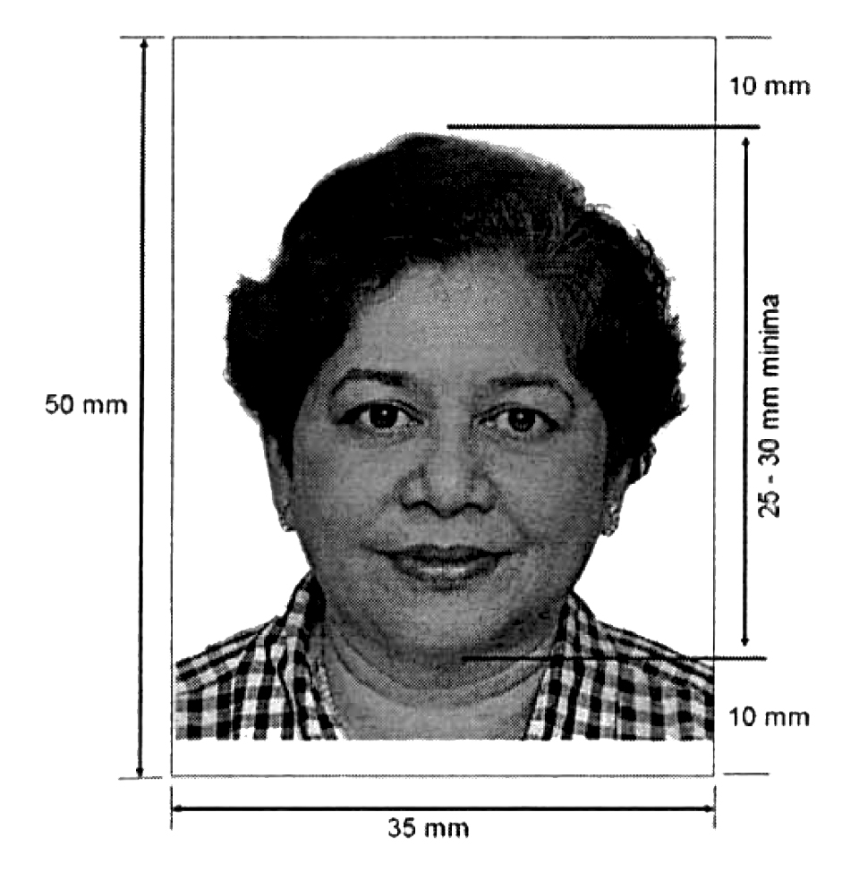

- Size: 35 mm by 50 mm
- Color: Taken in natural color. No black and white or any filters.
- Head size and position: The head should measure 25 mm to 30 mm. Squared with camera.
- Recency: Not older than six months.
- Background: White only. No colors, prints or patterns.
- Smile: No smiling. Mouth closed.
- Ear: Completely visible.
- Eyes: Completely visible.
- Glasses: Only if prescription and show eyes.
- Headgears: Religious purposes only.
- Dimensions and size (pixels): None specified.
- Attire, clothing, dress code: Dark clothing which contrasts the background.
- Beard: optional.
- Quantity needed in application 2.

